Name: Nafinur Leo

Id: 20-42195-1

Section: H

**Analysis of series RLC Circuit:**

Series RLC circuits consist of a resistance, a capacitance and an inductance connected in series across an alternating supply. In a series RLC circuit containing a resistor, an inductor and a capacitor the source voltage VS is the phasor sum made up of three components, VR, VL and VC with the current common to all three. Since the current is common to all three components it is used as the horizontal reference when constructing a voltage triangle. The impedance of the circuit is the total opposition to the flow of current. For a series RLC circuit, and impedance triangle can be drawn by dividing each side of the voltage triangle by its current, I. The voltage drop across the resistive element is equal to I*R, the voltage across the two reactive elements is I*X = I*XL – I*XC while the source voltage is equal to I*Z. The angle between VS and I will be the phase angle, θ. When working with a series RLC circuit containing multiple resistances, capacitance’s or inductance’s either pure or impure, they can be all added together to form a single component. For example, all resistances are added together, RT = (R1 + R2 + R3) etc. or all the inductance’s LT = (L1 + L2 + L3) etc. this way a circuit containing many elements can be easily reduced to a single impedance.

**Analysis of parallel RLC Circuit:**

In a parallel RLC circuit containing a resistor, an inductor and a capacitor the circuit current is the phasor sum made up of three components, IR, IL and IC with the supply voltage common to all three. Since the supply voltage is common to all three components it is used as the horizontal reference when constructing a current triangle. Parallel RLC networks can be analyzed using vector diagrams just the same as with series RLC circuits. However, the analysis of parallel RLC circuits is a little more mathematically difficult than for series RLC circuits when it contains two or more current branches. So, an AC parallel circuit can be easily analyzed using the reciprocal of impedance called Admittance. Admittance is the reciprocal of impedance given the symbol, Y. Like impedance, it is a complex quantity consisting of a real part and an imaginary part. The real part is the reciprocal of resistance and is called Conductance, symbol Y while the imaginary part is the reciprocal of reactance and is called Susceptance, symbol B and expressed in complex form as: Y = G + jB.

**Multisim simulation:**

**Series RLC circuit:-**

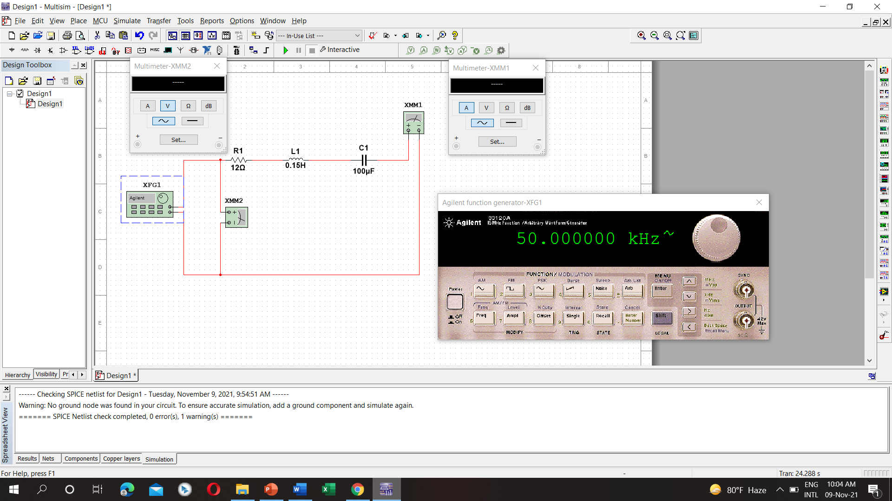

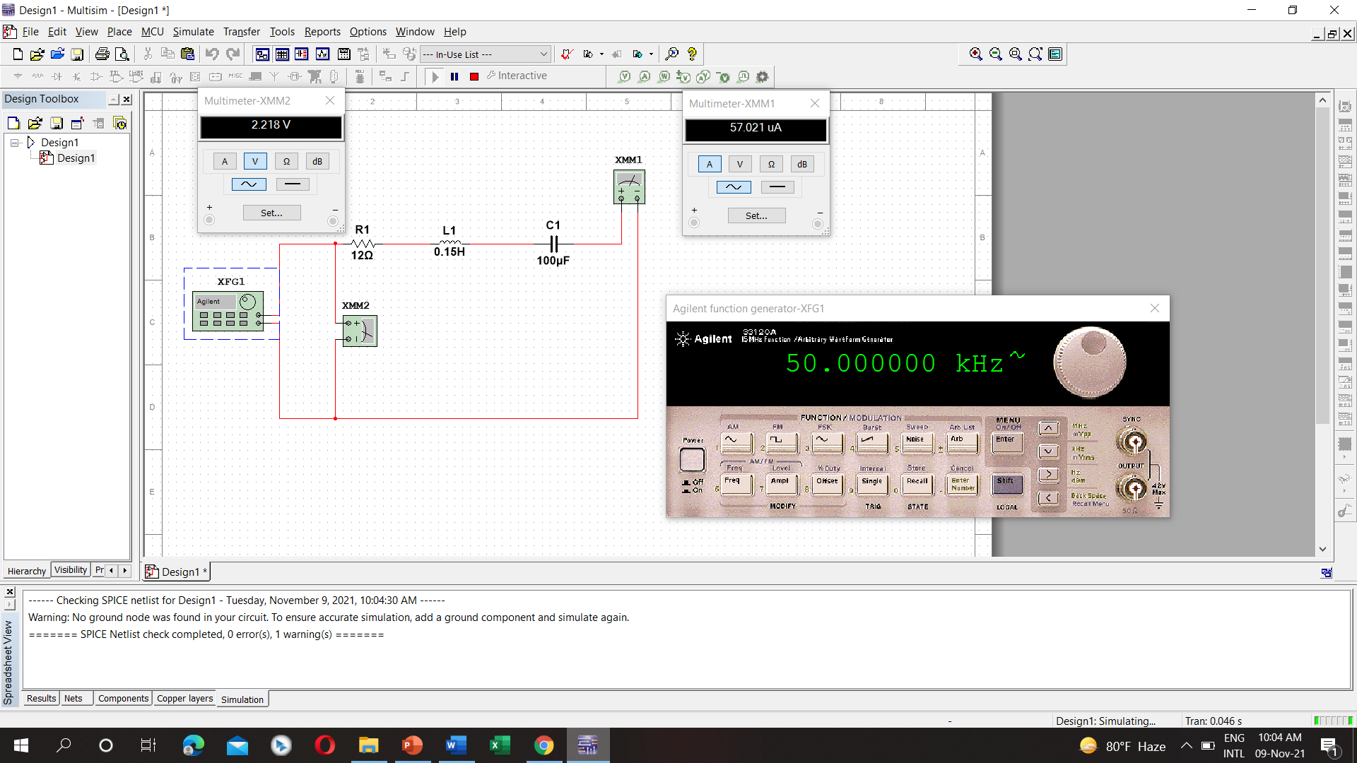

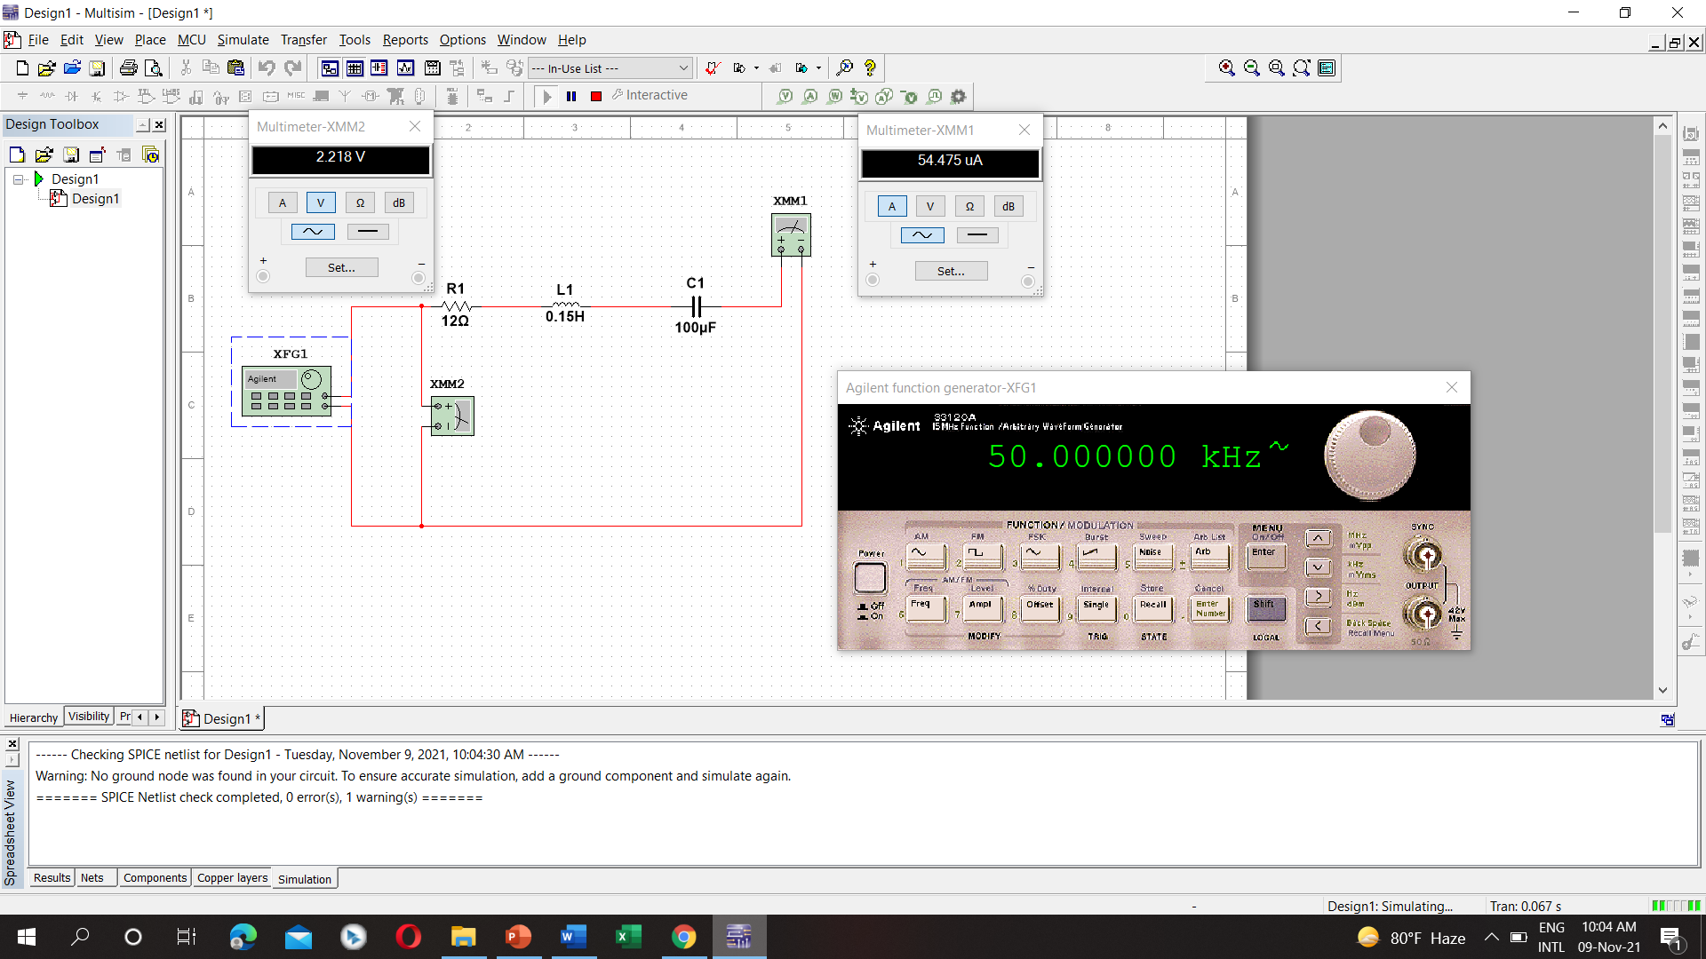

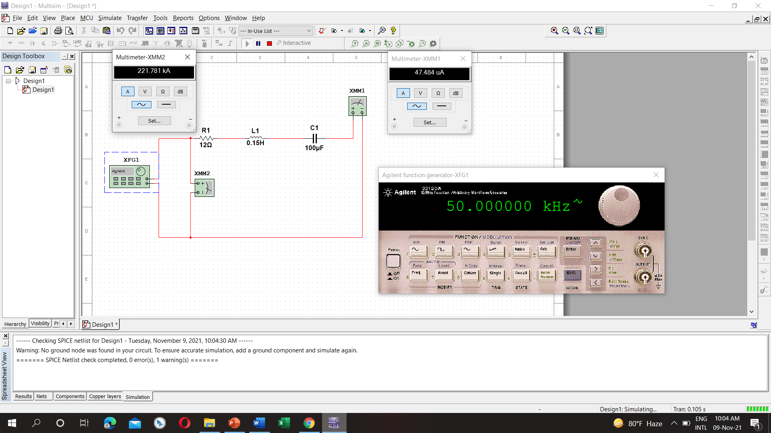

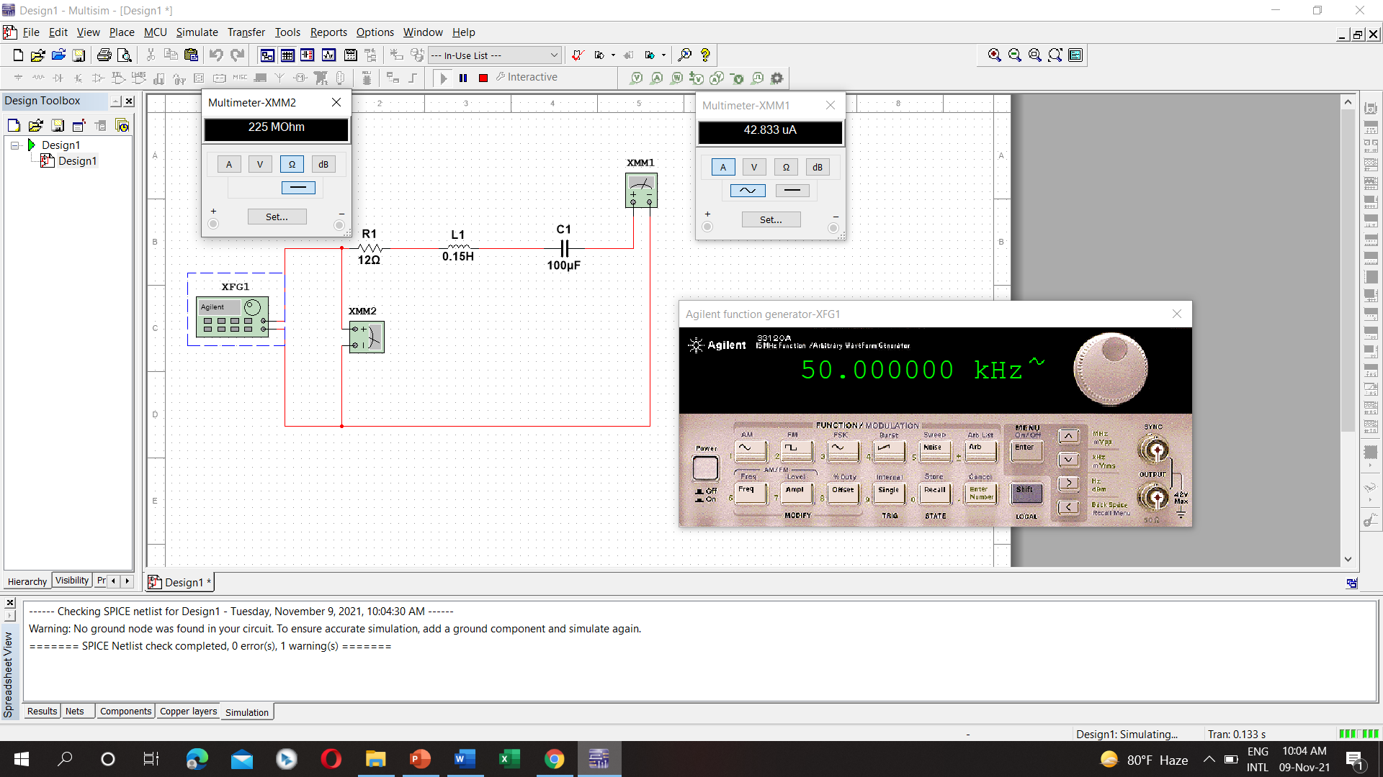

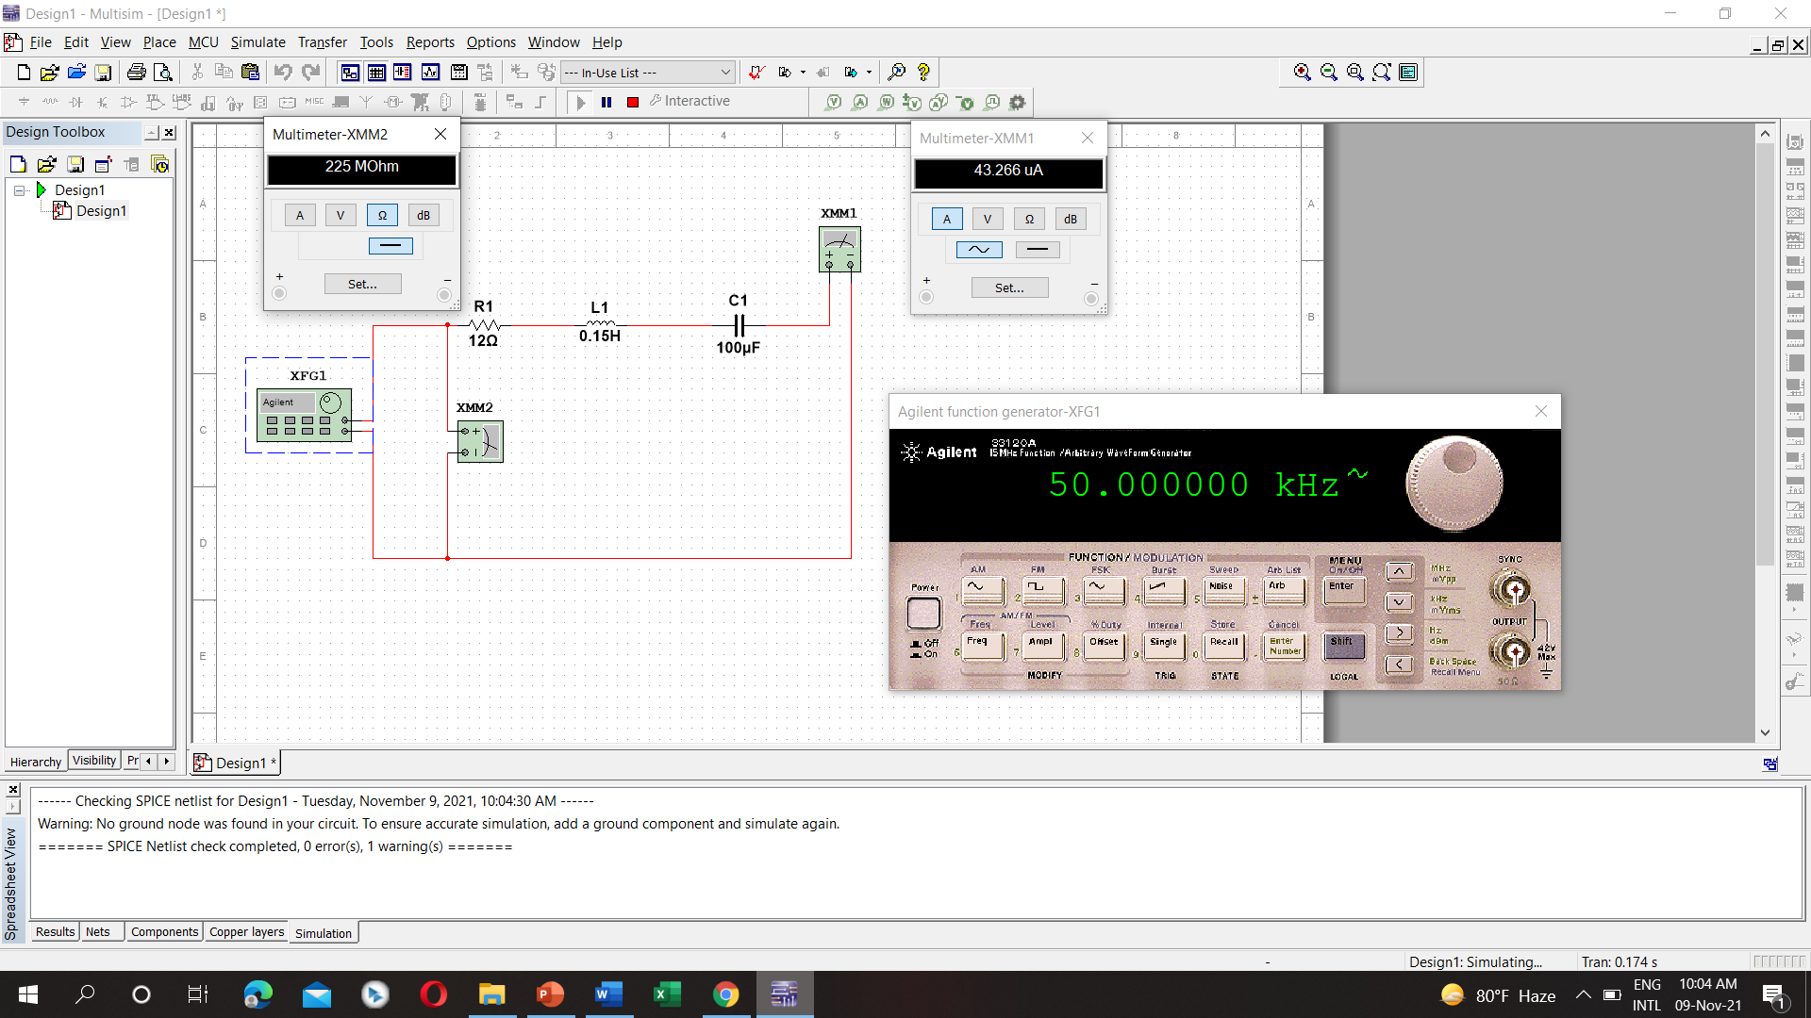

**Parallel RLC circuit:-**

